SIMATS ENGINEERING (SAVEETHA SCHOOL OF ENGINEERING)
Department of Computer Science and Engineering
CO4 ASSESSMENT TOOL 2 – CI/CD Pipeline Design Exercise

Course Code: | CSA10 | Course Title: | Software Engineering
CO Assessed: | CO4 | Assessment: | Assessment Tool 2 – CI/CD Pipeline Design Exercise
Weightage: | 20% | Total Marks: | 25
CO4 Statement: | Implement robust testing, quality assurance, and DevOps practices, emphasizing security, reliability, and ethics
Student Name: | K Sujith Sai Vighnesh | Reg. No.: | 192311199
Date: | 18-08-2026 | Duration: | 60 minutes

Code of Conduct
I K Sujith Sai Vighnesh --- 192311199 certify that this submission is my original work and that I have adhered to the guidelines specified for this assessment. I understand that any violation of academic integrity rules will result in disciplinary action.
Signature of the Student: K Sujith Sai Vighnesh____________
Annexure A – CI/CD Pipeline Design Exercise
Instructions to Students:
Each student is assigned an individual problem statement. Based on the assigned problem statement, design a CI/CD (Continuous Integration and Continuous Deployment) pipeline for the proposed software system to automate the processes of code integration, building, testing, and deployment.
The exercise should include:
- Analyze the project requirements and identify the CI/CD needs of the assigned problem statement.
- Design the CI/CD pipeline workflow showing stages such as source code management, build, testing, code quality analysis, packaging, and deployment.
- Identify suitable tools and technologies for each stage of the pipeline and justify their selection.
- Define appropriate automated testing strategies to be integrated into the pipeline.
- Design the deployment strategy, including development, testing/staging, and production environments.
- Incorporate appropriate security, quality checks, notifications, and rollback mechanisms in the pipeline.
- Prepare a CI/CD pipeline diagram and explain the workflow from code commit to deployment.
Deliverable: Submit a CI/CD Pipeline Design document containing the pipeline architecture/diagram, stages, tools, configuration/workflow, testing strategy, deployment process, and justification based on the assigned problem statement.

Rubrics for Calculation
Evaluation Criteria | Excellent (4 Marks) | Good (3 Marks) | Satisfactory (2 Marks) | Needs Improvement (1 Mark)
Requirement & Pipeline Analysis(15%) | Clearly analyzes the assigned problem and identifies comprehensive CI/CD requirements | Identifies most relevant requirements | Identifies basic requirements with some gaps | Requirements are unclear or incomplete
Pipeline Architecture & Workflow(25%) | Designs a complete, logical pipeline covering source, build, test, quality check, package, and deployment stages | Pipeline covers most major stages with minor gaps | Basic pipeline is designed but several stages are missing | Pipeline is incomplete or poorly structured
Tools & Technology Selection(20%) | Selects appropriate tools for each stage and provides clear justification | Appropriate tools selected with reasonable justification | Tools are identified but justification is limited | Tools are inappropriate or not clearly identified
Automated Testing & Quality Integration(15%) | Effectively integrates automated testing and code-quality/security checks into the pipeline | Includes major testing and quality checks | Includes basic testing with limited integration | Testing/quality checks are missing or inappropriate
Deployment, Security & Rollback Strategy(15%) | Clearly designs deployment environments, security practices, monitoring, and rollback strategy | Covers deployment and most security/rollback aspects | Basic deployment strategy with limited security/rollback details | Deployment strategy is incomplete or lacks security considerations
Pipeline Diagram & Documentation(10%) | Clear, accurate, professional diagram with excellent explanation and documentation | Well-presented diagram and documentation with minor issues | Adequate diagram/documentation but lacks clarity | Poorly presented, incomplete, or difficult to understand

AI-Powered Smart Disaster Relief Resource Allocation and Coordination Platform
CO4 Assessment Tool 2 – Software Engineering (CSA10)

1. Industry Context & Requirement Analysis
During natural disasters (floods, earthquakes, cyclones, wildfires), relief organizations — government disaster-management agencies, NGOs, hospitals, and volunteer networks — must rapidly allocate food, medicine, shelter capacity, and rescue equipment to affected zones. Traditional, manually coordinated allocation is slow, poorly synchronized across agencies, and often wastes resources by sending surplus to one zone while another remains under-served. The proposed platform uses AI-driven optimization, GIS-based geospatial mapping, IoT sensor feeds (from ground teams, drones, and depots), and cloud infrastructure to make allocation decisions in near real time and coordinate multiple agencies on a shared platform.

1.1 System Components
- AI/ML Allocation Engine: Optimization models that match available resources to demand hotspots based on severity, population density, and accessibility.
- GIS Mapping Service: Renders affected zones, road accessibility, and resource depots on interactive maps for field coordination.
- IoT Data Ingestion: Continuous telemetry from field sensors, drones, and vehicle trackers feeding real-time situational data.
- Multi-Agency Coordination APIs: Interfaces allowing government bodies, NGOs, and hospitals to share and consume resource-status data.
- Real-Time Dashboards: Command-center visualizations for decision-makers to monitor allocation status and bottlenecks.
- Mobile Field App: Used by ground responders to report status, request resources, and receive dispatch instructions with limited connectivity.

1.2 CI/CD Requirements Derived from the Domain
- Frequent, multi-team integration: Separate AI/ML, backend, GIS, and mobile teams commit continuously and require fast, automated integration feedback to avoid conflicting changes reaching production.
- High reliability and near-zero downtime: The system is disaster-critical — outages during an active event directly delay relief delivery and endanger lives, so the pipeline must support zero/low-downtime releases.
- Fast, safe rollback: A defective release cannot remain live; the pipeline must detect failure and restore the last known-good version within minutes, automatically wherever possible.
- Strong security and data protection: The platform processes sensitive victim location, medical need, and personal identification data, so every stage must include vulnerability and dependency scanning plus encryption controls.
- Elastic scalability: Traffic and IoT data volume spike sharply the moment a disaster is declared, requiring auto-scaling infrastructure validated under load before go-live.
- Auditability: Every deployment, rollback, and configuration change must be logged, since relief agencies may need to audit system behavior after an incident.

2. Pipeline Architecture & Workflow
The pipeline below traces every code change from developer commit through to monitored, auto-scalable production deployment, with a built-in automated rollback path if any health check fails after release.

2.1 Pipeline Flow Diagram
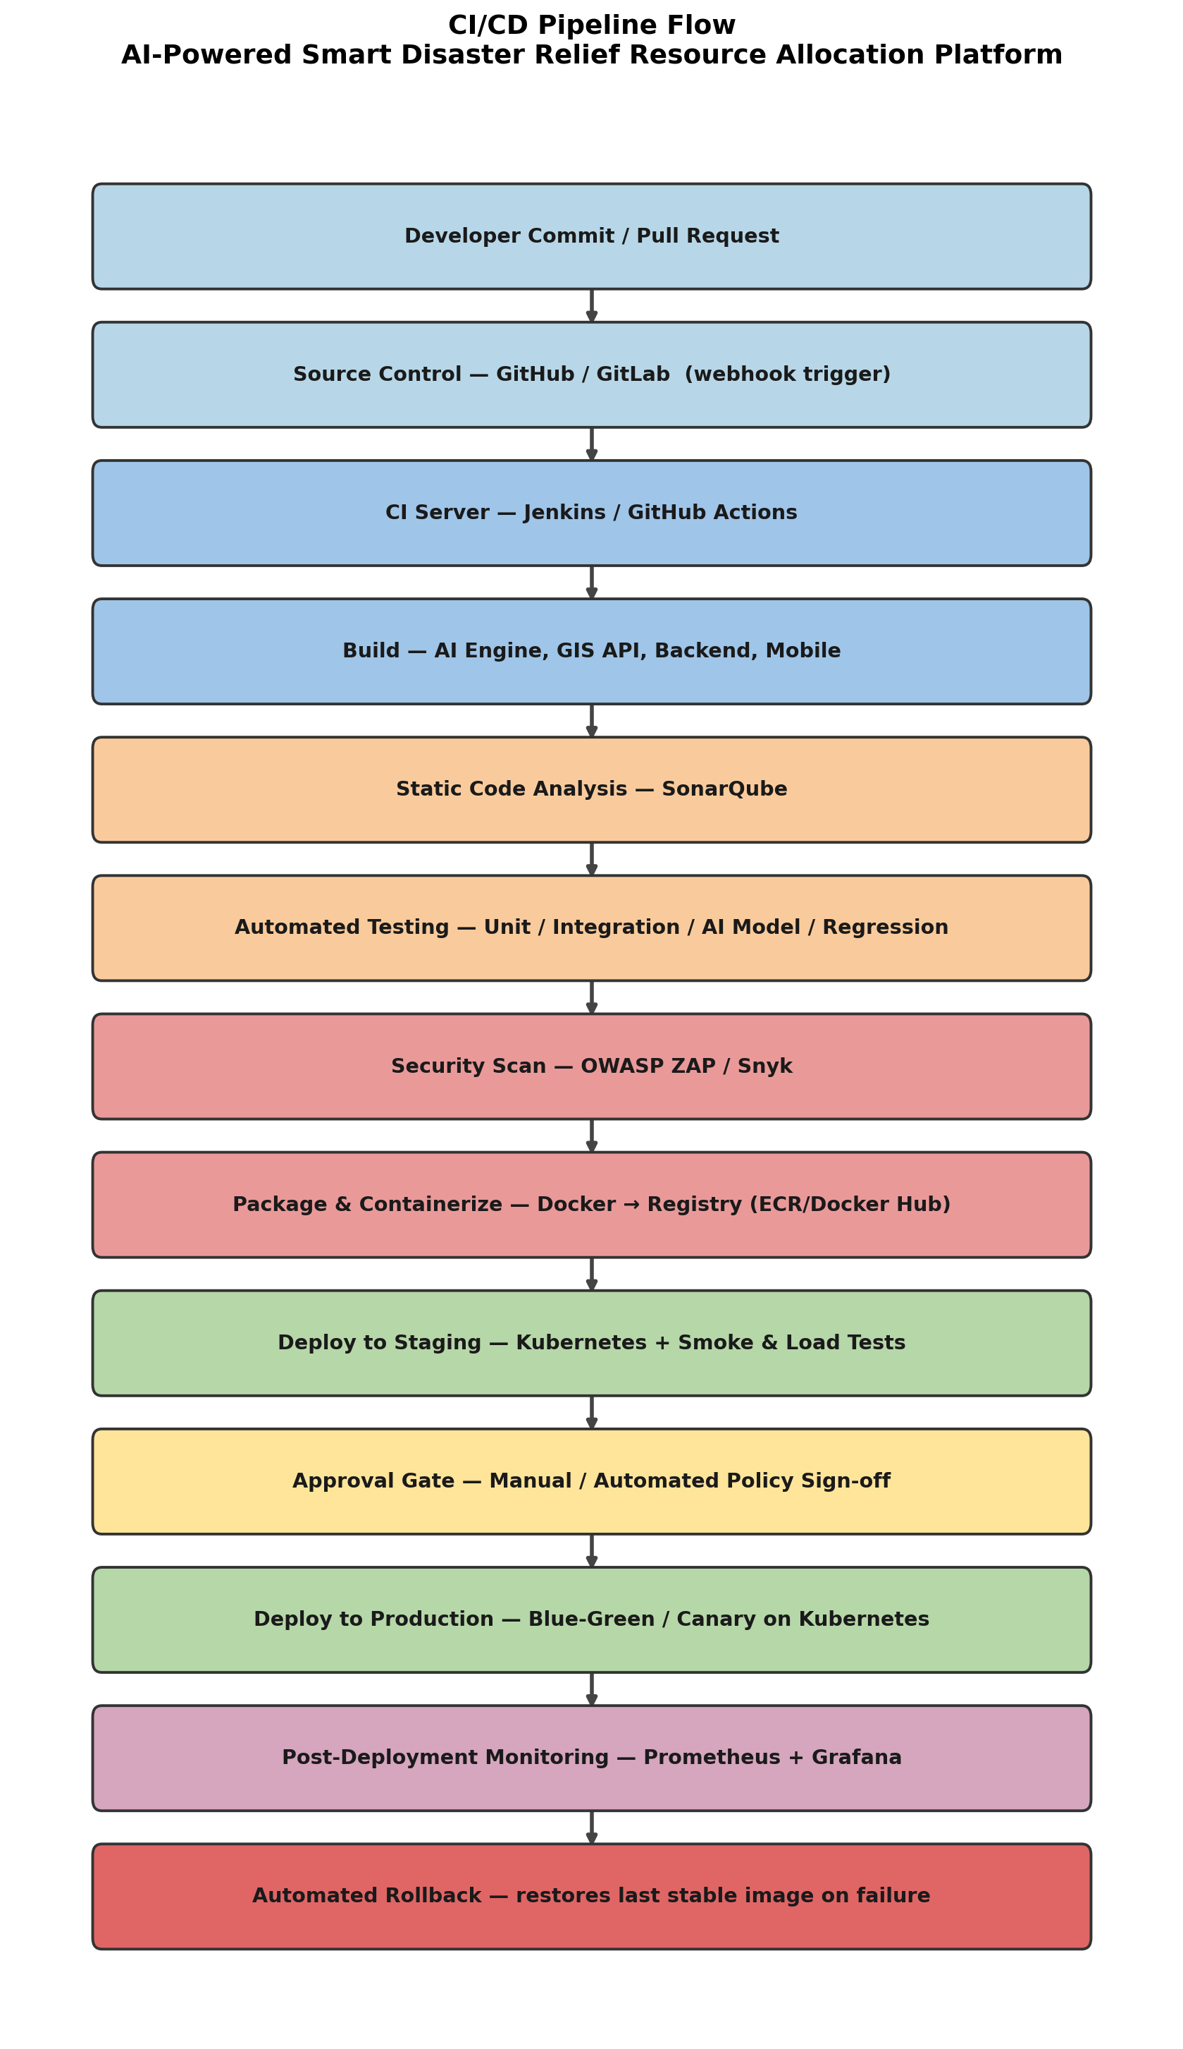

2.2 Text Representation of the Pipeline
[Developer Commit / Pull Request]
|
[Source Control: GitHub/GitLab] --(webhook trigger)-->
|
[CI Server: Jenkins / GitHub Actions]
|
[Build Stage]
-> compile & build microservices: AI allocation engine, GIS API,
backend/coordination services, mobile app bundle
|
[Static Code Analysis]
-> SonarQube: code smells, bugs, maintainability, security hotspots
|
[Automated Testing Suite]
|- Unit Tests (JUnit / PyTest)
|- Integration Tests (backend <-> GIS <-> IoT data flow, API contracts)
|- AI Model Validation (allocation accuracy vs. benchmark disaster scenarios)
\- Regression Tests (previous critical workflows still pass)
|
[Security Scan]
-> OWASP ZAP (dynamic scan) + Snyk (dependency/SCA scan)
|
[Package / Containerize]
-> Docker image build per microservice -> push to registry (Docker Hub / Amazon ECR)
|
[Deploy to Staging Environment]
-> Kubernetes staging cluster -> smoke tests + load/stress tests
|
[Quality Gate / Manual Approval]
-> Release manager or automated policy sign-off before production
|
[Deploy to Production]
-> Blue-Green or Canary deployment on Kubernetes (AWS/Azure), multi-region
|
[Post-Deployment Monitoring]
-> Prometheus + Grafana dashboards; Slack/Email alerts on anomalies
|
[Automated Rollback Trigger]
-> If health checks / error-rate thresholds fail, traffic reverts to last
stable image automatically and the team is notified

2.3 Stage-by-Stage Explanation
- Source Code Management: Developers work on feature branches and raise pull requests. Each push and PR automatically triggers the CI server via a webhook, ensuring no manual step is needed to start validation.
- Build: All four core services (AI engine, GIS API, coordination backend, mobile bundle) are compiled/built independently so a failure in one does not block visibility into the others.
- Static Code Analysis: SonarQube inspects the newly built code for bugs, code smells, and security hotspots and blocks the pipeline if the configured quality gate is not met.
- Automated Testing: Unit, integration, AI-model validation, and regression tests run in sequence (or in parallel jobs) so functional defects are caught before packaging.
- Security Scanning: Dynamic scanning (OWASP ZAP) tests the running application for vulnerabilities such as injection or misconfiguration, while Snyk audits open-source dependencies for known CVEs.
- Packaging: Each verified service is containerized with Docker for environment consistency and pushed to a versioned image registry.
- Staging Deployment: The containerized build is deployed to a production-like Kubernetes staging cluster, where smoke tests confirm basic functionality and load tests simulate disaster-scale concurrent usage.
- Approval Gate: A release manager (or an automated policy based on test/security results) signs off before the change is allowed into production, adding a human or policy checkpoint for a life-critical system.
- Production Deployment: Blue-green deployment keeps the previous stable version live while the new version is verified, or canary deployment shifts a small percentage of real traffic first — both approaches minimize the blast radius of a bad release.
- Monitoring & Rollback: Prometheus collects metrics and Grafana visualizes them; if error rate, latency, or health-check thresholds are breached, the pipeline automatically rolls back to the last stable image and alerts the team.
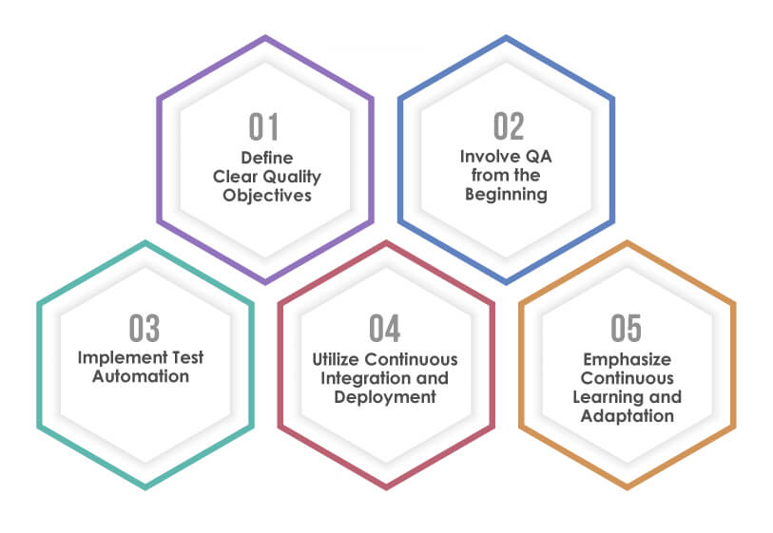

3. Tools & Technology Selection
Each stage uses a tool chosen specifically for the demands of a large-scale, multi-agency, disaster-critical system.
Stage | Tool | Justification
Source Control (SCM) | GitHub / GitLab | Branching, pull-request reviews, and webhook triggers start the pipeline automatically on every commit; enables parallel work by AI, backend, GIS, and mobile teams.
CI/CD Orchestration | Jenkins / GitHub Actions | Automates the build-test-deploy sequence end to end; large plugin ecosystem and native integration with Docker and Kubernetes.
Code Quality Analysis | SonarQube | Static analysis catches bugs, code smells, and security hotspots before code is merged, enforcing a consistent quality gate across all teams.
Containerization | Docker | Packages each microservice (AI engine, GIS API, backend, mobile) with its dependencies so behavior is identical across dev, staging, and production.
Container Orchestration | Kubernetes | Auto-scales services to absorb disaster-time traffic spikes and self-heals by restarting failed pods without manual intervention.
Security Scanning | OWASP ZAP, Snyk | ZAP dynamically tests the running app for vulnerabilities; Snyk audits dependencies for known CVEs — both critical given sensitive victim/location data.
Cloud Platform | AWS (EC2, S3, RDS, Lambda) / Azure | Provides elastic compute, storage, managed databases, and serverless functions that support GIS and IoT data integration at scale.
Monitoring & Observability | Prometheus + Grafana | Collects and visualizes real-time metrics (latency, error rate, resource usage) needed for a life-critical uptime commitment.
Notifications | Slack / Email (via CI hooks) | Sends immediate alerts to the DevOps team on build, test, security, or deployment failure so incidents are triaged within minutes.
Secrets Management | HashiCorp Vault / AWS Secrets Manager | Keeps API keys, database credentials, and third-party tokens out of source code and pipeline logs.

4. Automated Testing Strategy
Testing is layered so that cheap, fast checks run first and catch most defects early, while deeper checks (AI validation, load testing) run later in the pipeline against a fully packaged build.
Test Type | Scope | Tooling
Unit Testing | Validates individual functions/modules in isolation — allocation logic, GIS lookup functions, IoT data parsers. | JUnit (Java), PyTest (Python/AI)
Integration Testing | Confirms the AI engine, GIS service, backend, and IoT ingestion pipeline exchange data correctly end-to-end. | Postman/Newman, PyTest
AI Model Validation | Runs the resource-allocation model against benchmark disaster scenarios and checks output accuracy against defined thresholds before promotion. | Custom validation harness
Regression Testing | Re-runs prior critical test suites to ensure new changes have not broken existing coordination workflows. | Selenium / API regression suite
Load & Stress Testing | Simulates disaster-scale concurrent requests from field teams and citizens in the staging environment. | JMeter / k6
Security Testing | Dynamic and dependency scanning to catch vulnerabilities before code reaches staging. | OWASP ZAP, Snyk
Smoke Testing | A lightweight suite runs immediately after each deployment (staging and production) to confirm core services are up before full traffic is allowed. | Custom health-check scripts

5. Deployment Strategy

5.1 Environments
- Development: Feature branches auto-deploy to isolated, short-lived containers for early developer feedback on every push.
- Staging / Testing: A production-like Kubernetes cluster where integration, AI-model, load, and security tests run against the fully packaged build before promotion.
- Production: Multi-region cloud deployment (AWS/Azure) sized for disaster-time load, released using blue-green or canary deployment to avoid downtime.

5.2 Deployment Approach
Blue-green deployment maintains two identical production environments — blue (current live) and green (new release). Traffic is switched to green only after it passes automated health checks, and blue is kept on standby so rollback is an instant traffic-switch rather than a rebuild. Canary deployment is used for higher-risk releases: a small percentage of live traffic (e.g., 5%) is routed to the new version first, and the rollout expands gradually only while error rates and latency remain within acceptable limits. This limits the impact of a faulty release on a system where downtime has real-world safety consequences.

5.3 Release Cadence
Standard feature releases follow a scheduled weekly cadence promoted through staging with full test and approval gates. Critical hotfixes (e.g., a bug affecting live disaster response) bypass the standard cadence but still pass through the same automated test and security stages before an expedited canary release, ensuring speed never comes at the cost of a completely unvalidated deployment.

6. Security, Quality Checks, Notifications & Rollback
- Security Practices: Static (SonarQube) and dynamic (OWASP ZAP) scans plus dependency scanning (Snyk) run at build time; secrets are managed via Vault/Secrets Manager rather than stored in code; data in transit is encrypted with TLS and data at rest is encrypted given the sensitive victim/location data involved; role-based access control restricts which agencies can view or modify which data.
- Quality Gates: The pipeline automatically blocks promotion to the next stage if code coverage, static-analysis, or security-scan thresholds are not met — no manual override for critical severity findings.
- Notifications: Slack/email alerts trigger on build failure, test failure, security-scan failure, and deployment failure or rollback, ensuring the responsible team is notified within minutes, not after the next standup.
- Rollback Mechanism: Prometheus/Grafana continuously monitor post-deployment health metrics (error rate, latency, pod restarts); if thresholds are breached, the pipeline automatically redirects traffic back to the last stable image (blue-green) or halts and reverses a canary rollout, minimizing downtime for a disaster-response system.
- Audit Logging: Every pipeline run, approval, deployment, and rollback is logged with timestamp and actor, supporting post-incident audits that relief agencies may require.
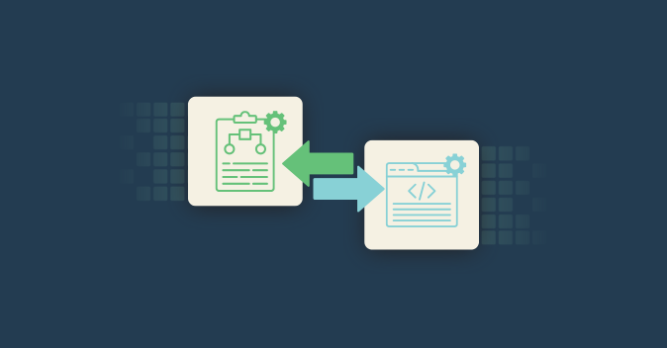

7. Sample Pipeline Configuration (Illustrative)
A simplified representation of how the pipeline stages would be expressed in a GitHub Actions / Jenkins-style YAML configuration, showing the sequential job dependencies described in Section 2.
name: disaster-relief-ci-cd
on: [push, pull_request]

jobs:
build:
steps: [checkout, build-ai-engine, build-gis-api, build-backend, build-mobile]

static-analysis:
needs: build
steps: [sonarqube-scan]

test:
needs: static-analysis
steps: [unit-tests, integration-tests, ai-model-validation, regression-tests]

security-scan:
needs: test
steps: [owasp-zap-scan, snyk-dependency-scan]

package:
needs: security-scan
steps: [docker-build, docker-push-to-ecr]

deploy-staging:
needs: package
steps: [kubectl-apply-staging, smoke-tests, load-tests]

approval-gate:
needs: deploy-staging
steps: [manual-approval]

deploy-production:
needs: approval-gate
steps: [blue-green-switch or canary-rollout]

monitor-and-rollback:
needs: deploy-production
steps: [prometheus-healthcheck, auto-rollback-on-failure]

8. Risk Assessment & Mitigation
Key operational risks specific to a disaster-response system and how the pipeline design mitigates each one.
Risk | Impact | Mitigation Built into Pipeline
Deployment failure during an active disaster | Loss of coordination capability at a critical moment | Blue-green/canary deployment with automated health-check-based rollback restores service within minutes.
Undetected security vulnerability in dependencies | Exposure of sensitive victim/location data | Snyk dependency scanning and OWASP ZAP dynamic scanning run on every build before packaging.
Traffic spike overwhelming the system at disaster onset | Dashboard/API unavailability for responders | Load/stress testing in staging plus Kubernetes auto-scaling validated before production release.
Faulty AI allocation model reaching production | Misallocation of food, medicine, or rescue teams | Dedicated AI model validation stage benchmarks accuracy before the model is promoted.
Configuration drift between staging and production | Bugs that only appear in production | Docker containerization keeps environments identical across dev, staging, and production.
Delayed incident response | Extended downtime during an active relief operation | Automated Slack/email alerts on any pipeline or production failure ensure immediate visibility.

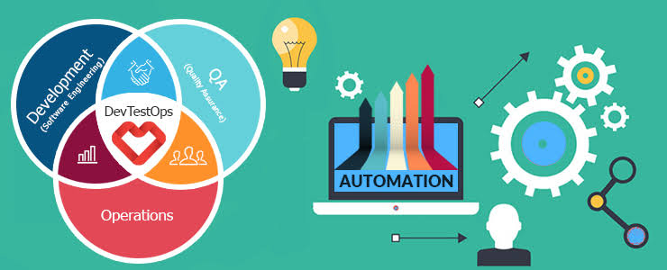

9. Conclusion
This CI/CD pipeline automates the full journey from code commit to production deployment for the AI-powered disaster relief platform. It integrates automated build and static analysis, a layered testing strategy that includes AI model validation and load testing, dynamic and dependency-based security scanning, and a blue-green/canary deployment strategy backed by automated health-based rollback. Together, these practices ensure the platform remains reliable, secure, auditable, and rapidly deployable — qualities that are essential for a system directly supporting time-critical, life-saving disaster response coordination across multiple agencies.

